**Appendix 2 to**

**Annex H to**

**BAMA Rules and Regulations**

**Dated Jan 25**

**INCIDENT MANAGEMENT AND REPORTING INSTRUCTION**

References:

1. [JSP 751 Joint Casualty and Compassionate Policy and Procedures](https://modgovuk.sharepoint.com/sites/defnet/HOCS/Documents/JSP751_Part1_Vol1.pdf)
2. [2024DIN06-027-Annual Defence Road Safety Awards](https://modgovuk.sharepoint.com/sites/DINs/_layouts/15/Doc.aspx?sourcedoc=%7B634FD149-E321-4B8D-92A3-293B326954B9%7D&file=2024DIN06-027-Annual%20Defence%20Road%20Safety%20Award%202025.docx&action=view&mobileredirect=true&DefaultItemOpen=1)
3. [2024DIN06-024-The Defence Accident Investigation Branch](https://modgovuk.sharepoint.com/sites/DINs/_layouts/15/Doc.aspx?sourcedoc=%7B4E257007-E572-4BBA-AF4A-AE95197D2ABA%7D&file=2024DIN06-024-The%20Defence%20Accident%20Investigation%20Branch.docx&action=view&mobileredirect=true&DefaultItemOpen=1)
4. [AGAI Vol 1, Chap 5, Sport](https://armysportcontrolboard.com/wp-content/uploads/2017/10/AGAI_005.pdf)
5. [MYSAFETY User manual, Issue 2](https://jive.defencegateway.mod.uk/servlet/JiveServlet/downloadBody/1085820-102-16-1619601/MySafety%20User%20Manual.pdf)

**General**

1. All disciplines within BAMA are to use this instruction to manage, and report, Incidents, involving Service Personnel (SP), which occur during BAMA supported events. Each event will be supported by an Administration Instruction (AI) which will list those classed as ‘on duty’ however this instruction also applies to all SP in attendance.

**Aim**

1. The aim of this instruction is to provide a standard management and reporting process for all disciplines within BAMA and act as a guide for individuals who have no prior experience in incident management to follow.

**Action**

1. **Prelims**. This instruction is to be added to the AI or Addendum as an Annex.
2. At the beginning of each event, the Activity Deliverer will place a hard copy of the AI into a folder along with:
3. An up-to-date nominal roll of all SP in attendance including visitors.
4. A paper copy of each ‘on duty’ SP unit Pt1 Orders.
5. At the beginning of each event, the Activity Deliverer is to the brief all personnel on the location and contents of the folder and the importance of social media discipline following an incident.
6. **Method**. In the case of an Accident, Serious Incident, Incident or Near Miss, an Incident SPOC (Single Point of Contact) shall be identified. The Incident SPOC is to the access the folder and follow the flow chart at Fig 1 using information available within the other documents where applicable. The Incident SPOC should be in constant contact with other participants so that any TRiM requirements can be identified at the event.
7. The Incident SPOC shall alert the Risk Owner through the Signal reporting chain.
8. Where possible it should be the injured party who initiates the MYSAFETY Alert as this will go to their unit for further input as a MYSAFETY Report. Where this is not possible, the Incident SPOC should initiate the Alert. The Incident SPOC shall keep a record of all telephone calls made using Fig 2.
9. **Exemption**. The only exemption to this instruction is where an SP is serving as part of, or with a unit where name and details may be withheld. Where this is the case the incident controller shall contact the exchange on Tel: 01432 357311.
10. **Close down**. The MYSAFETY SPOC is to keep in contact with outside authorities for as long as is deemed necessary. The MYSAFETY SPOC should remain the Single Point of Contact for outside authorities unless otherwise detailed (this may be a substantial time following the event). The MYSAFETY SPOC should be able to keep all individuals informed of any developments throughout. Where a MYSAFETY Report is closed down by an individual’s unit, that SP should inform the MYSAFETY SPOC.
11. The Discipline Operations Manager should contact each participating individual’s parent unit so they can be made aware if there is any requirement for TRiM post event where necessary.

**BAMA Incident Management Instruction**

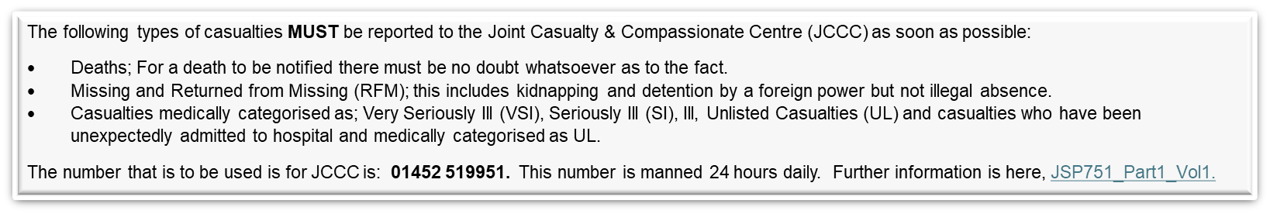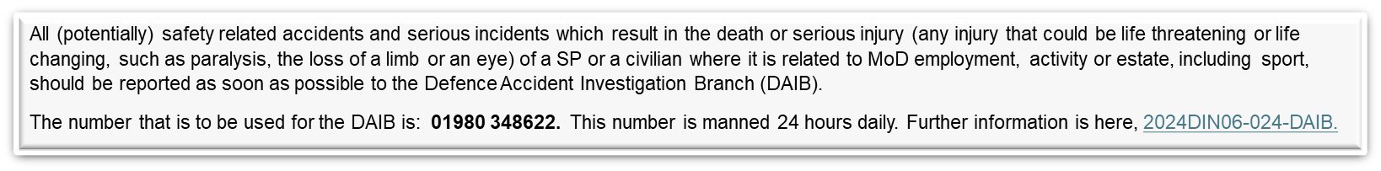**Figure 1.** Incident reporting flowchart

As a general rule, any incident/accident involving a knock to the head or back/neck or limbs where that SP is required to drive away from the event, should be seen by the event medical staff prior to dispersal.

As per paragraph 8, a MYSAFETY Alert should ideally be raised by the individual involved. This ensures that person has access rights if the report requires additional information at a later date. Raising a MYSAFETY Alert does not automatically inform any other organisation.

**Incident Call Register**

|  |  |  |  |
| --- | --- | --- | --- |
| **DTG** | **Caller** | **Receiver** | **Outline of call** |
|  |  |  |  |
|  |  |  |  |
|  |  |  |  |
|  |  |  |  |
|  |  |  |  |
|  |  |  |  |
|  |  |  |  |
|  |  |  |  |
|  |  |  |  |
|  |  |  |  |
|  |  |  |  |
|  |  |  |  |
|  |  |  |  |
|  |  |  |  |
|  |  |  |  |
|  |  |  |  |
|  |  |  |  |

**Figure 2.** Call Register

**Intentionally left blank**